# [Law & Order: SVU – Stabler spin-off delayed amid showrunner change](https://cartermatt.com/417700/law-order-svu-stabler-spin-off-delayed-amid-showrunner-change/)

[Law & Order: Organized Crime](https://cartermatt.com/tag/law-order-organized-crime/), [Law & Order: SVU](https://cartermatt.com/tag/law-order-svu/) October 2, 2020

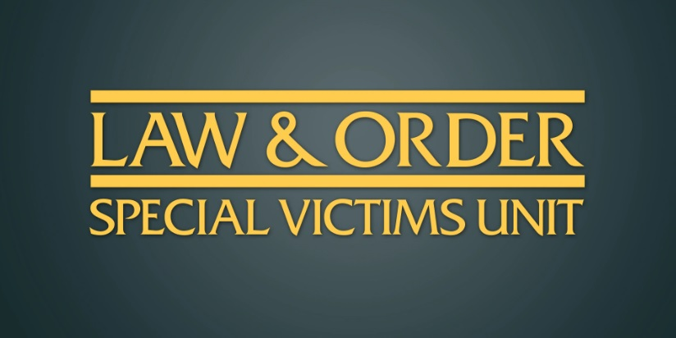While it seems like you are still going to see *Law & Order: Organized Crime* at some point during the 2020-21 TV season, you will have to wait a while.

According to the [Hollywood Reporter](https://www.hollywoodreporter.com/live-feed/chris-melonis-law-order-svu-spinoff-delayed-at-nbc-amid-showrunner-change-exclusive), *One Chicago* alum Matt Olmstead is going to be departing his post as showrunner amid creative differences, which means that there could be a wait now to see who steps into this role. The [*Law & Order: SVU*](https://cartermatt.com/tag/law-order-svu/) spin-off is facing further delays now to production — it has not even revealed a full cast yet other than Christopher Meloni as Stabler.

Read More

Typically, delaying a new show isn’t altogether complicated — here, though, it could be. *SVU* is probably going to cross over with the world of *Organized Crime* at some point this season, or this at least is the hope. The issue is that it’s hard for *SVU* to solidify any plans for a crossover when they don’t know when the other show is going to air. Our feeling is that they may prepare a potential story idea (there was originally going to be a setup for one at the end of season 21) that they can use whenever they are able to, but everything will remain somewhat touch-and-go for now.

At present, we know that *SVU* proper is underway filming season 22 in New York, with the plan for it to premiere at some point next month. The show is planning to tackle a number of real-world issues early on, and we’ve already heard (read here) that some characters who surfaced last season will be back in a much larger role.

Still, we can’t help but say that a Stabler – Benson reunion is one of the things that we are the most excited for — let’s just hope that it happens in 2021, if it takes that long for *Organized Crime* to eventually premiere.

### What are you hoping to see from *Law & Order: Organized Crime?*

Be sure to share some of your thoughts right now in the comments! Also, remember here to stick around if you are interested in scoring some additional news. (Photo: NBC.)

**This article was written by Jessica Carter. Be sure to follow her on** [**Twitter.**](https://twitter.com/dangergirl101/)